Tasks
1.
Find three logos of your favorite apps (like Instagram, Spotify, or Myntra) and identify which historical design movement (Bauhaus, Swiss Design, Minimalism) most influences each logo’s style. Write 2-3 lines explaining your reasoning for each.
2.
Create a digital poster (using Canva, Figma, or Photoshop) for a fictional music festival, inspired by the Bauhaus movement — use geometric shapes, bold colors, and sans-serif fonts.<br><br><em><strong>Hint:</strong> Search for 'Bauhaus poster' images for inspiration before you start designing.</em>
3.
Pick a famous brand (like Zomato, Paytm, or Flipkart) and research how their typography has evolved over the years. Collect at least two logo images from different years and describe how the typography changes reflect trends in graphic design.
4.
Given five sample posters (search online for 'Swiss Design posters'), identify and list at least three key features that make them part of the Swiss Design movement. Explain how these features could be used in a modern app UI.
5.
Design a minimalist promotional Instagram post for a new food delivery app — use only two colors, one font, and simple shapes to convey the message.<br><br><em><strong>Constraint:</strong> Avoid gradients, shadows, or complex illustrations; focus on clarity and simplicity.</em>
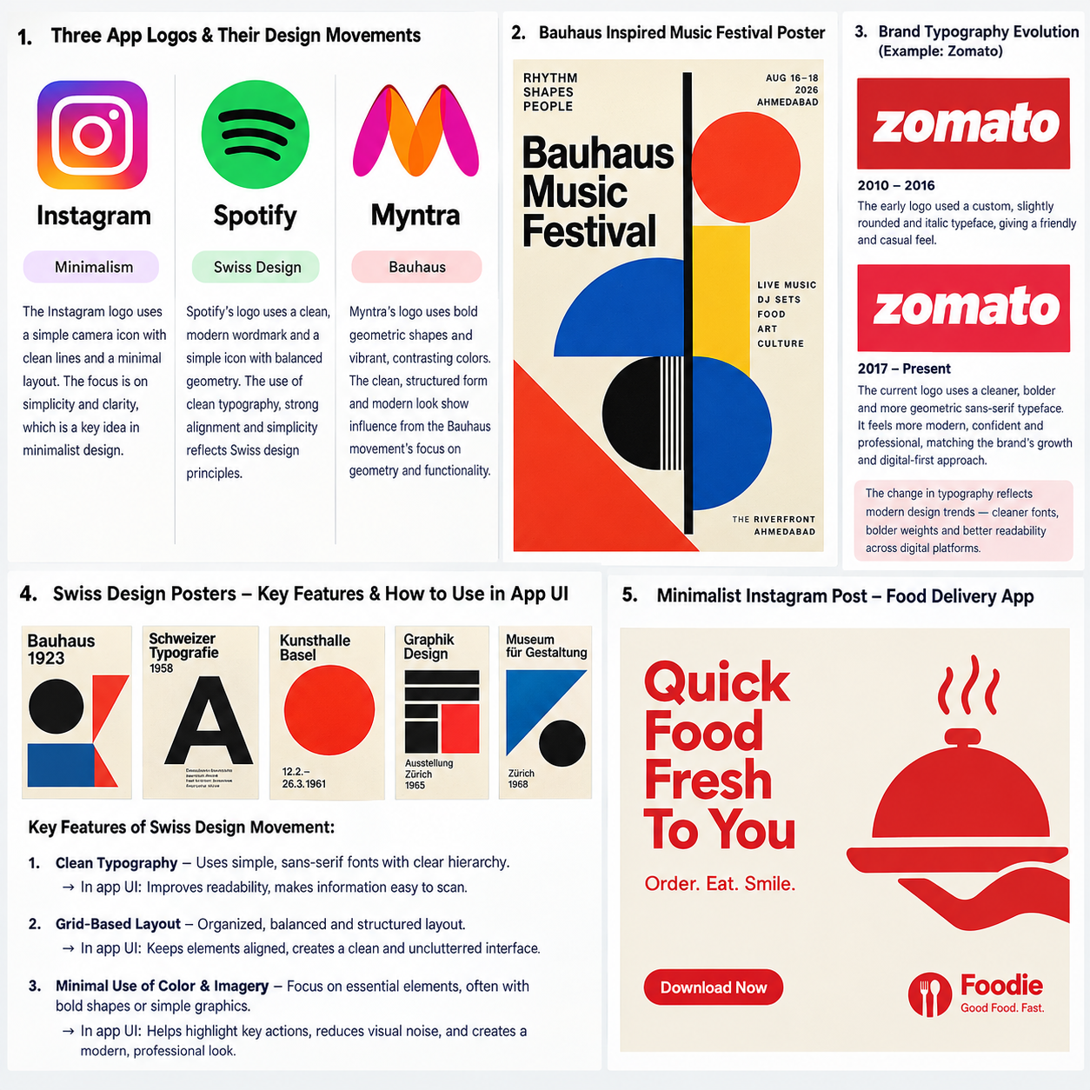
Tasks
1.
Open Canva or any design tool and redesign a cluttered event announcement poster by applying the principle of contrast — use different font weights, sizes, or colors to make the event title stand out from the rest of the content.
2.
Create a social media story slide for a music festival using repetition — repeat a graphic element (like a music note or wave) across the design to create visual rhythm and consistency.
3.
Design a simple mobile app splash screen (for a food delivery app like Zomato or Swiggy) that demonstrates alignment — ensure all text and logo elements are perfectly aligned either to the center or left edge for a clean, professional look.<br><br><em><strong>Hint:</strong> Use alignment guides in your design tool to check spacing and positioning.</em>
4.
Take a screenshot of a Flipkart or Myntra product page and annotate (draw arrows or labels) where you see the principles of proximity and hierarchy being used to group related information and highlight the most important details.
5.
Design a two-sided flyer for a college fest that shows balance and unity — arrange images and text so that both sides feel evenly weighted and all elements feel like they belong together.<br><br><em><strong>Hint:</strong> Try using a grid or mirrored layout to achieve balance.</em>
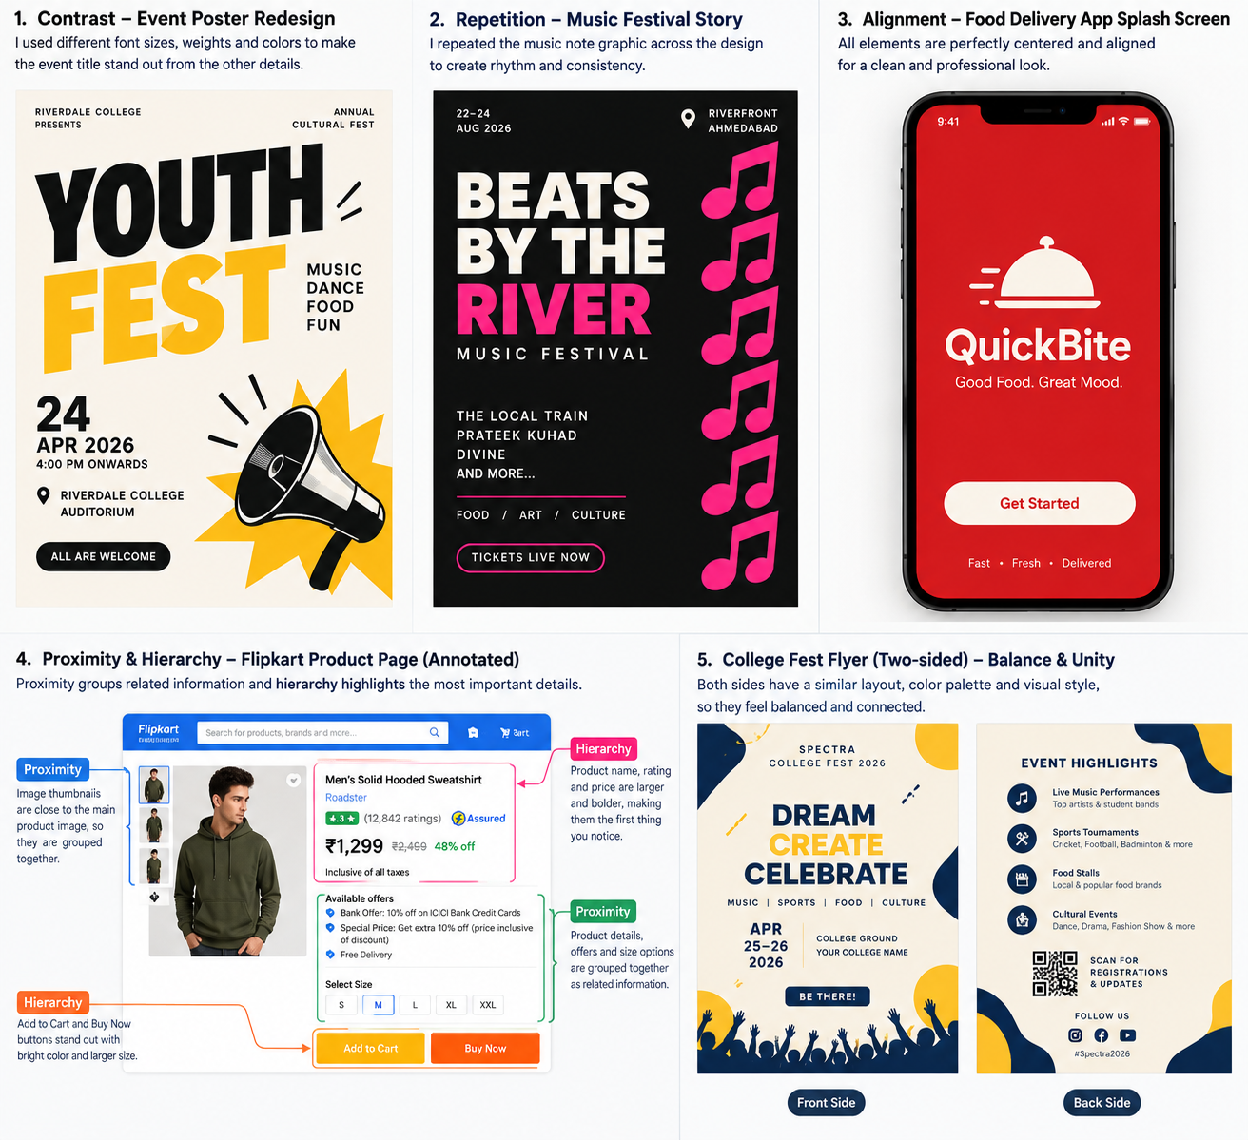
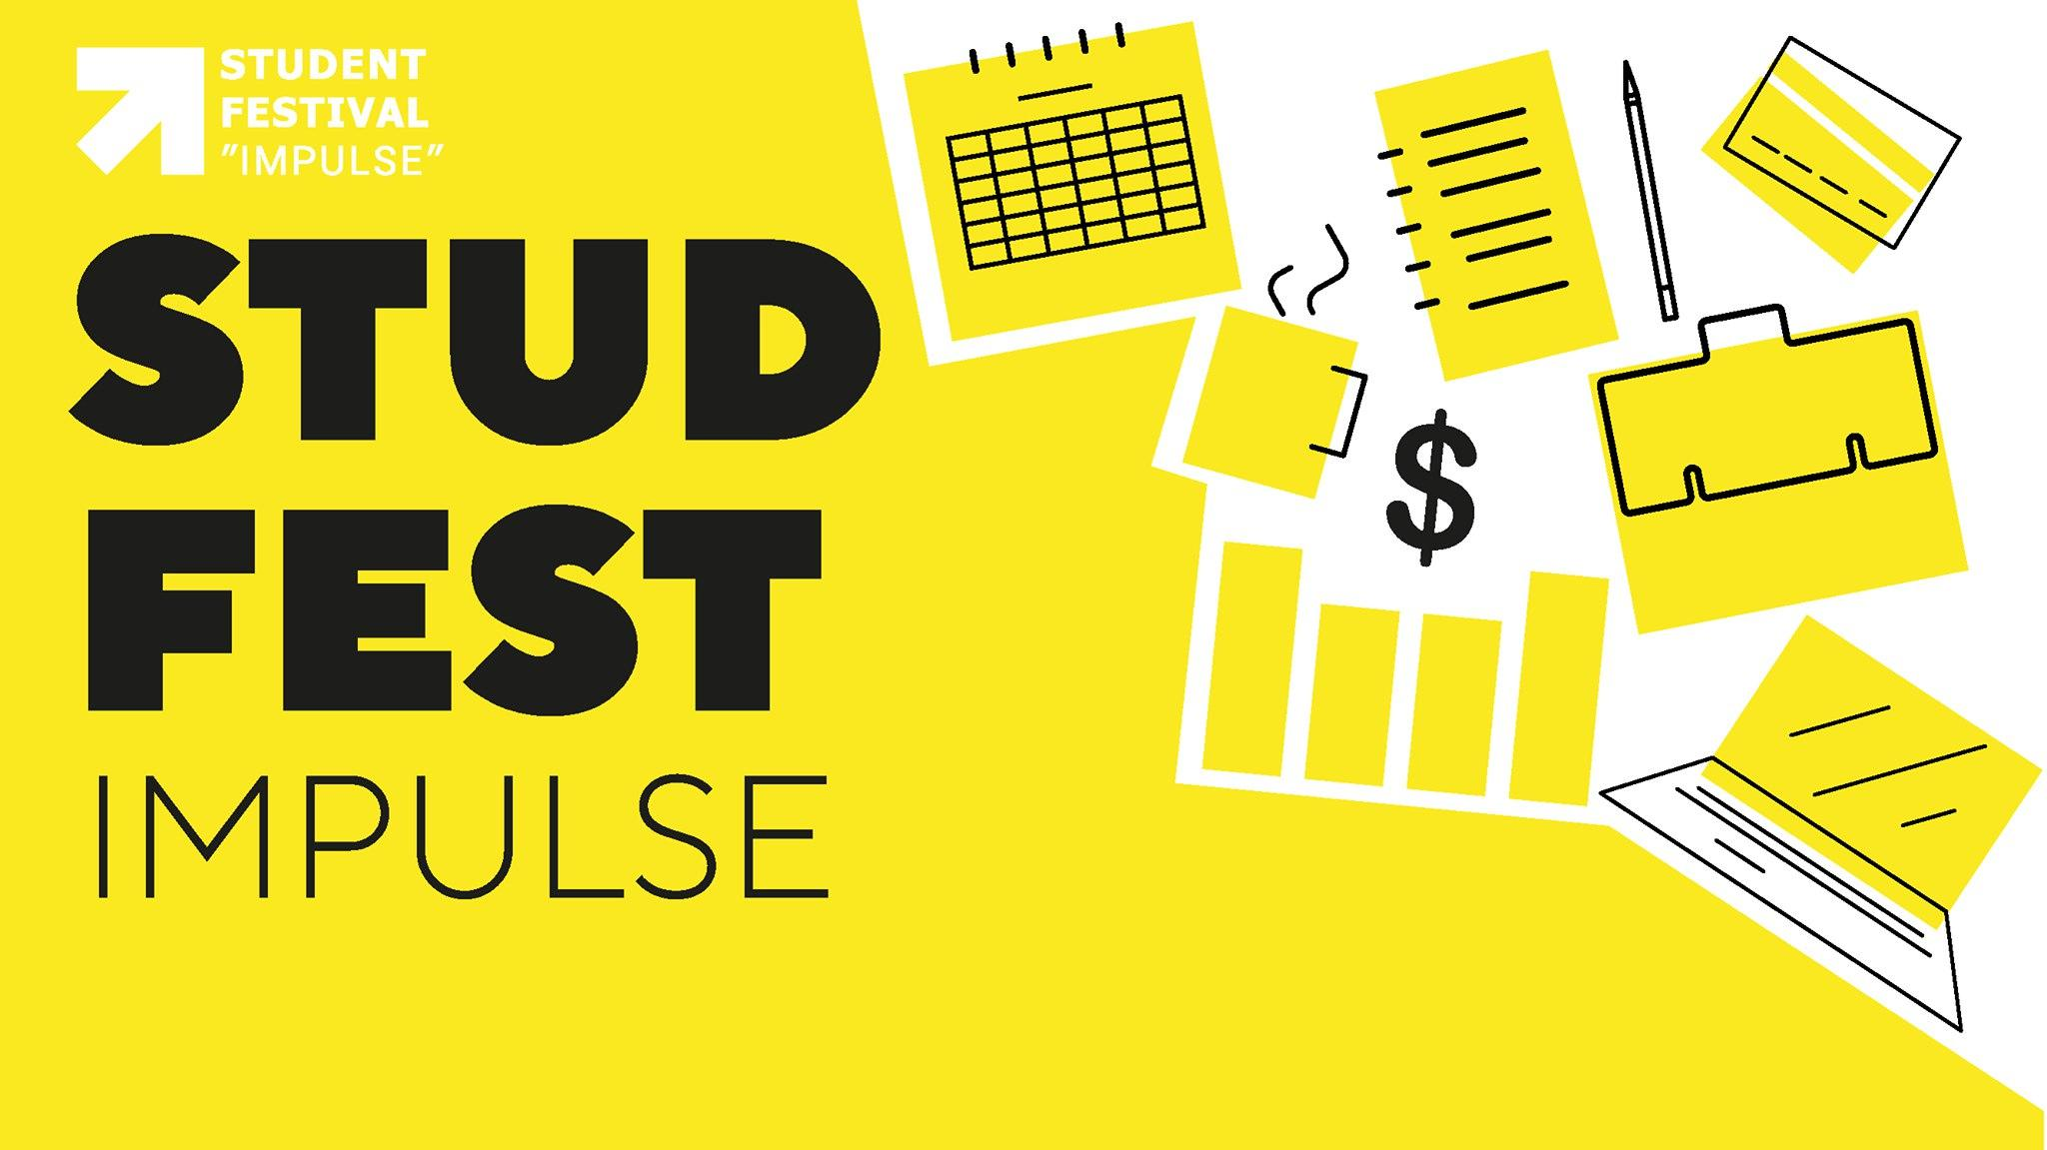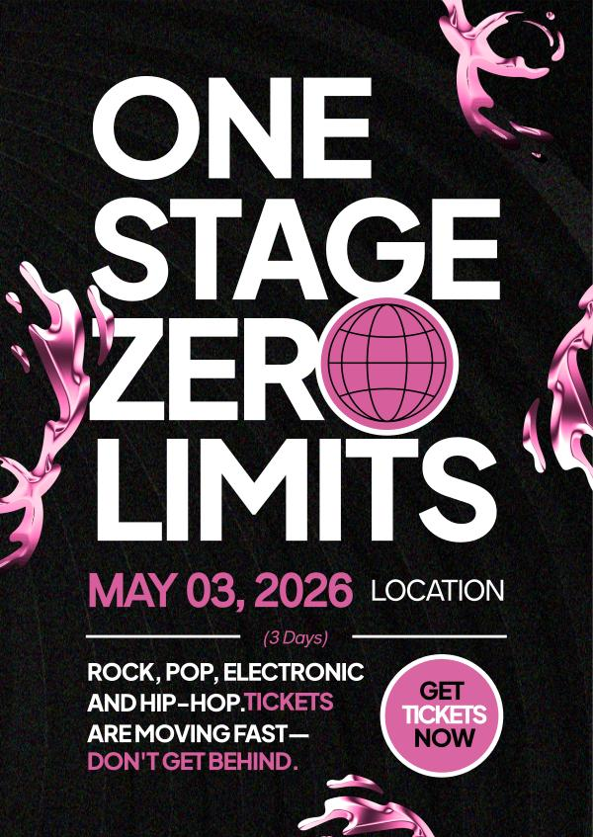
Tasks
1.
Open any image editing tool you know (Photoshop, Illustrator, Canva, or even MS Paint) and create two rectangles: fill one with an RGB color (e.g., pure red: #FF0000) and the other with the same color in CMYK mode (e.g., C:0 M:100 Y:100 K:0). Take a screenshot and note the visual difference between RGB and CMYK.
2.
Draw a basic color wheel with at least 12 segments showing primary, secondary, and tertiary colors. Label each segment and indicate which are considered warm and which are cool tones.<br><br><em><strong>Hint:</strong> Use colored pencils, markers, or any digital tool you like.</em>
3.
Pick any one color (for example, blue) and create three swatches: a tint (add white), a tone (add gray), and a shade (add black). Arrange them side by side and label each.
4.
Choose a popular app you use (like Instagram, Zomato, or Paytm) and analyze its main brand color. In a few sentences, explain what emotion or message this color likely conveys and why you think the designers chose it.<br><br><em><strong>Hint:</strong> Search for 'color psychology' if you need inspiration.</em>
5.
Take a screenshot of a real app or website homepage (for example, Flipkart or BookMyShow). Use arrows or highlights to show how the use of color guides your eye to the most important actions (like 'Buy Now', 'Book Tickets', or notifications).
